1. Labeled Diagram of a Desktop PC
Image generation requires you to log in. Once you're logged in, I can create a labeled desktop PC diagram showing the motherboard, CPU, RAM, GPU, HDD, and SSD.
For now, here is a simple labeled diagram you can use for your assignment.
Inside a Desktop Computer (PC Cabinet)
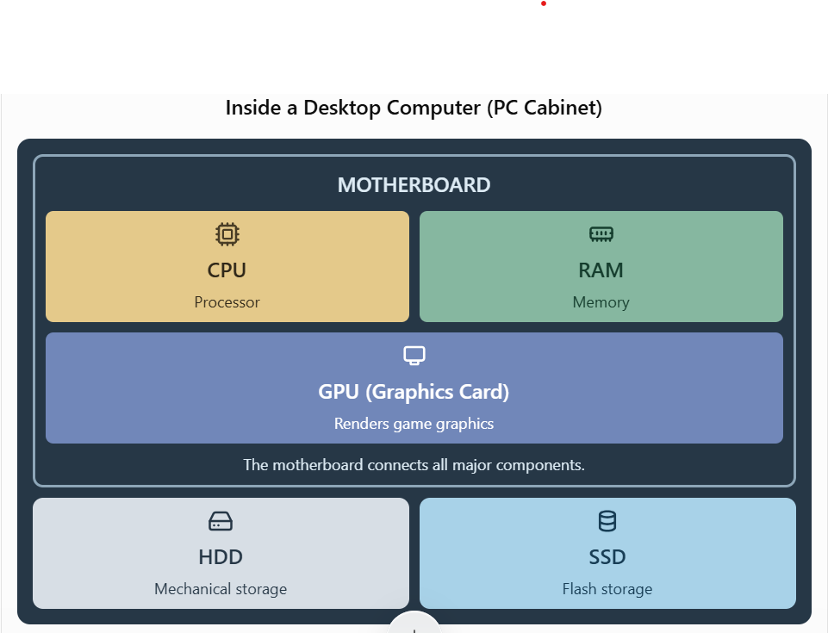
Note: The HDD and SSD connect to the motherboard or its storage interfaces. Their positions inside a PC cabinet can vary.

2. Comparison Between HDD and SSD
Feature | HDD (Hard Disk Drive) | SSD (Solid-State Drive)
Speed | Slower; has moving parts | Faster; uses flash memory
Durability | More sensitive to physical shocks | More shock-resistant
Noise | Can make noise while operating | Silent operation
Cost | Usually cheaper per GB | Usually more expensive per GB
Typical use | Large files, backups, and budget storage | Operating system, applications, and games
Gaming performance | Longer loading times are common | Faster game loading and level transitions
Conclusion: An SSD is generally better for gaming because it loads games and programs faster. An HDD is useful for storing large amounts of data at a lower cost.

3. Roles of CPU, RAM, and GPU in Gaming

CPU (Central Processing Unit)
The CPU is the brain of the computer and handles game logic, player movements, enemy actions, and other calculations. In games like PUBG or Free Fire, a powerful CPU helps the game run smoothly and reduces processing delays.

RAM (Random Access Memory)
RAM temporarily stores the game data and instructions that the CPU needs while the game is running. Having enough RAM helps prevent stuttering and allows the game and other background programs to run more smoothly.

GPU (Graphics Processing Unit)
The GPU renders the game's graphics, including characters, maps, lighting, shadows, and visual effects. A powerful GPU helps produce higher frame rates and better image quality, making gameplay smoother and more enjoyable.

4. Hardware Upgrades for Running the Latest FIFA Smoothly
To run the latest EA SPORTS FC (formerly FIFA) smoothly, I would consider the following upgrades.

1. Graphics Card (GPU)
I would upgrade to a suitable modern GPU because it handles the game's graphics and has a major impact on frame rates, resolution, and visual quality.

2. RAM
I would ensure the PC has enough RAM to meet the game's requirements. More memory can help reduce stuttering, especially when other applications are open.

3. CPU (Processor)
I would upgrade the CPU if it is too old or too slow for the game. A capable processor helps handle game calculations and maintain stable performance.

4. SSD Storage
I would install the game on an SSD to improve startup and loading times. I would also ensure there is enough free storage space for the game and its updates.

5. Power Supply Unit (PSU)
If the new graphics card requires more power, I would upgrade to a reliable PSU with sufficient wattage and the correct power connectors.
Final recommendation: I would check the official system requirements for the specific EA SPORTS FC version before buying hardware. The GPU, CPU, and sufficient RAM are especially important for smooth gameplay, while an SSD improves loading times. I would also check motherboard compatibility, cooling, and power requirements before upgrading.

